PRACTICAL NO:-2
Apply the what – if Analysis for data visualization. Design and generate necessary reports
based on the data warehouse data. Use Excel.
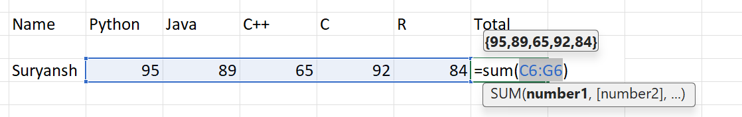
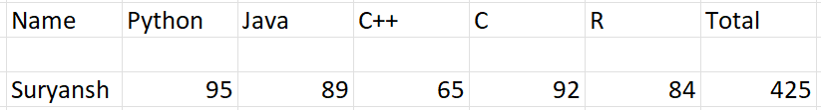
Now we will use what-if analysis to perform various operations.
What-if analysis is present in data.
1)Goal Seek:
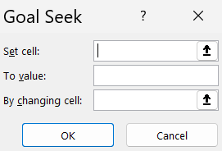
Here,
Set cell -which we will set the value.
To value -to defined the value that we want expected.
By changing cell-From which cell we will get the value.

Now here we will try to change the value of total cell to 450 by changing subject score of R.
OUTPUT: 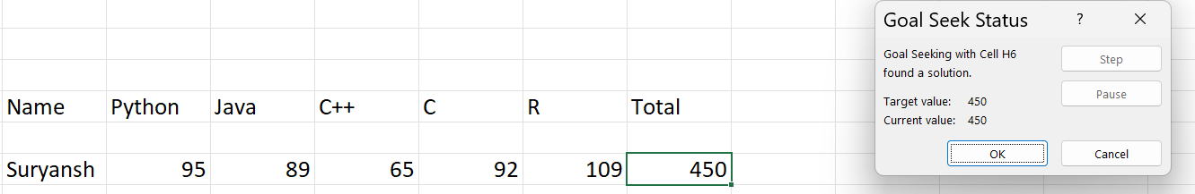

2)Scenario Manager:
Data:
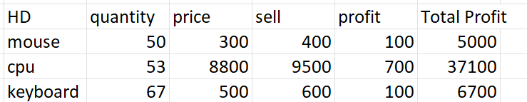

Now we will add two scenario where first one saleing at higher price than this and second one is increasing quantity.
- saleing at higher price:
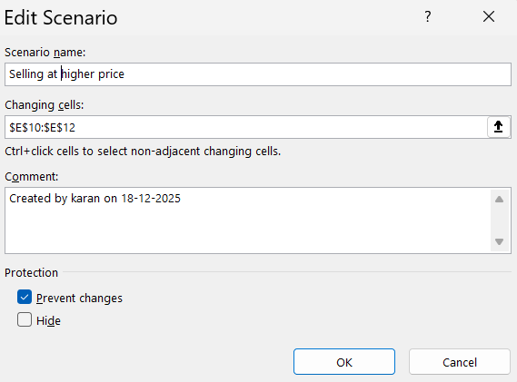
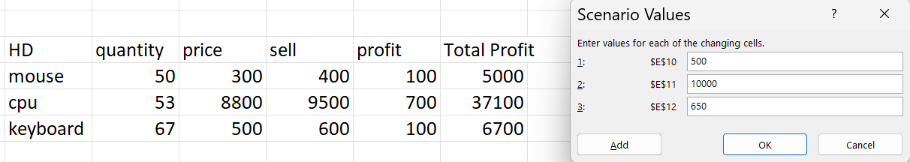

2)More quantity:
Now will increase the quantity and will check whether what will be the output will be:
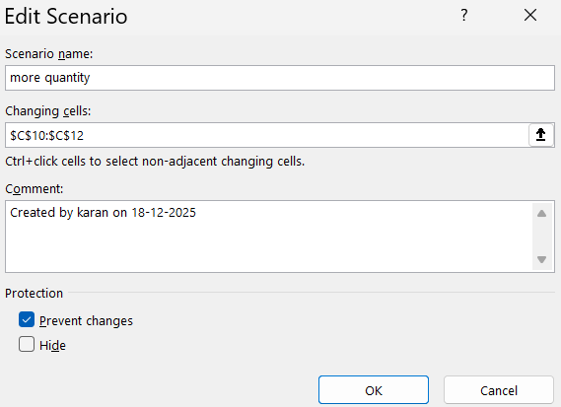
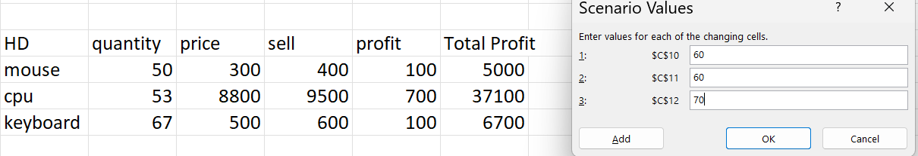

Now we will check summary of saleing at higher price and of more quantity as well:
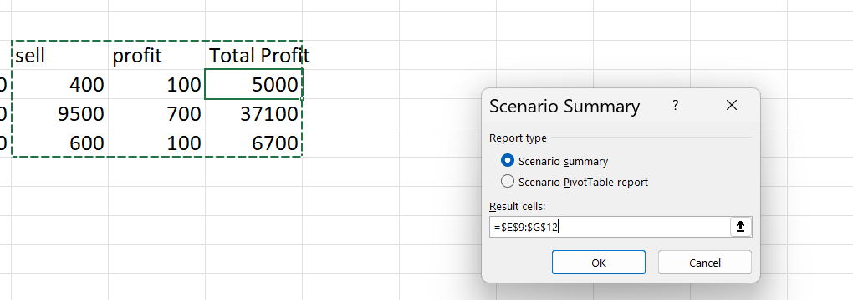

OUTPUT:
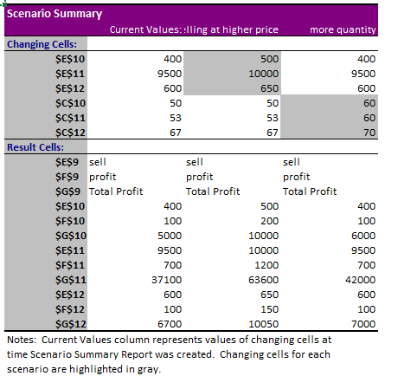

3)Data table:
A Data Table in Excel is a What-If Analysis tool used to see how changes in input values affect the result of a formula.
Data Table cannot use multiple cells
It needs ONE original input cell only.
Data:
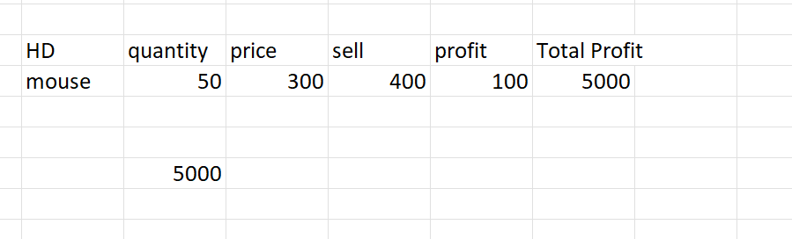
The total profit is 5000 as we can see now we will check at the different sale price what will be our total profit and select all columns:
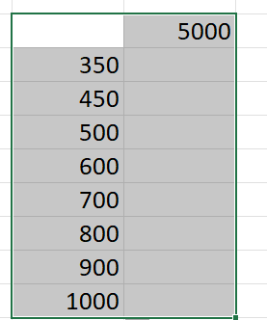
Now we will provide here above columns as a sales data since that is column value there.

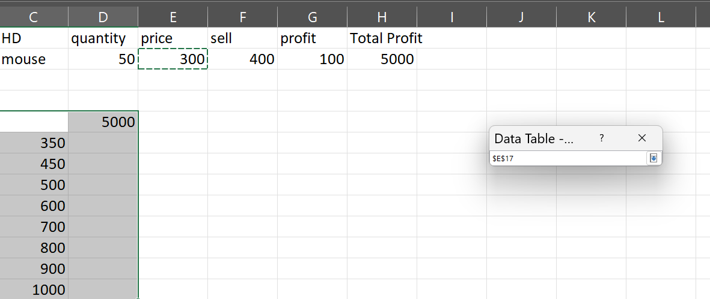
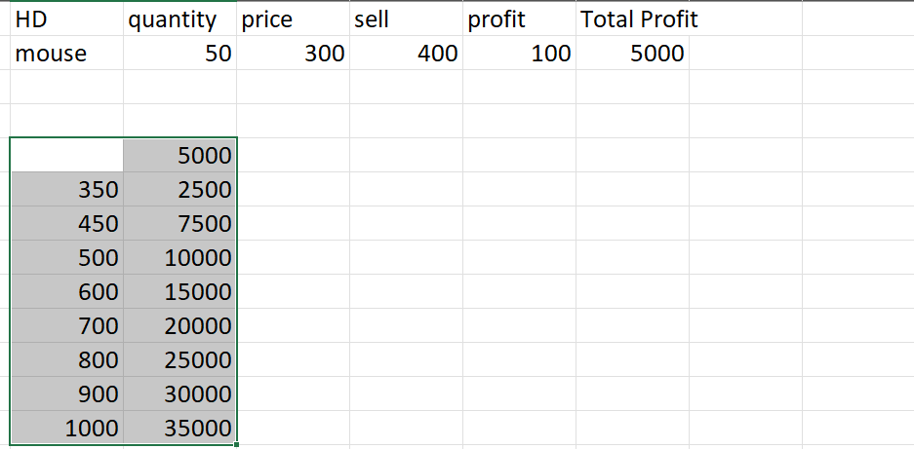
Now we will check for different sales price as well as the at different quantity
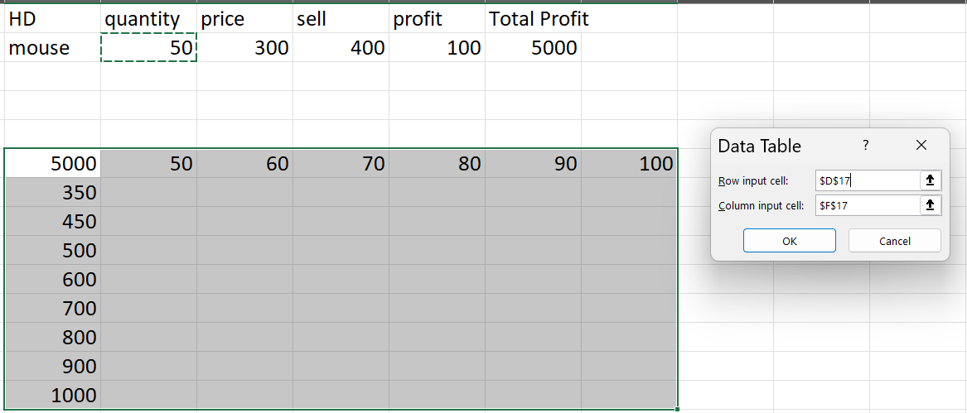
OUTPUT:
